The Ohio State University
First-Year Seminar Program
Course Proposal

Course Information

- Attach a syllabus that includes the following (sample syllabi can be found at http://firstyearseminars.osu.edu):

- the course goals
- a brief description of the content
- the distribution of meeting times
- a weekly topical outline
- a listing of assignments
- grade assessment information (A-E or S/U)
- required textbooks and/or reading list
- the academic misconduct and disability services statements (sample statements can be found at
http://asccas.osu.edu/curriculum/asc-syllabus-elements)

Instructor Information
- Attach a brief biographical paragraph that includes the current research interests, teaching awards and honors, and undergraduate courses taught by the participating instructor(s). The paragraph will be included in materials for first-year students.

Zoe Brigley Thompson, Engllish
Proposer’s Name and Primary Academic Unit (please print)

Assistant Professor (0.49)

Proposer’s Title

Thompson.3022@osu.edu

Proposer’s e-mail Address

2nd March 2020

Submission Date

Robyn Warhol 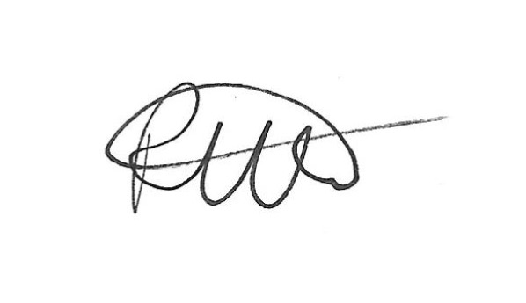

Approval of Department Chair of Academic Unit (please print)

Please return this form and any attachments to First-Year Seminar Program, 100 Denney Hall, 164 Annie & John Glenn Avenue, ATTN: Todd Bitters or e-mailed to bitters.4@osu.edu.
1/15/2019 tab

